Lesson3: Quiz

CS544 Enterprise Architecture

1. What is DAO Pattern?

Data Access Object Pattern or DAO pattern is used to separate low level data accessing API or operations from high level business services.

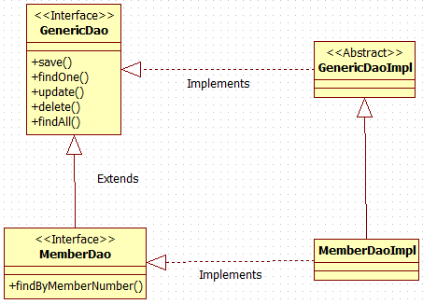

1. In JPA, an entity has 4 state: Managed, Transient, Detached, Removed. What’s the behavior of each state?

A transient entity has no database identity

A managed entity is managed by the persistence context (em) and has a DB identity

A detached entity has a database identity

But is not managed by the current persistence ctx.

A removed Entity is removed from the DB and persistence ctx

But the object may not yet be garbage collected in Java

1. What’s the difference between em.find() and em.getReference()?

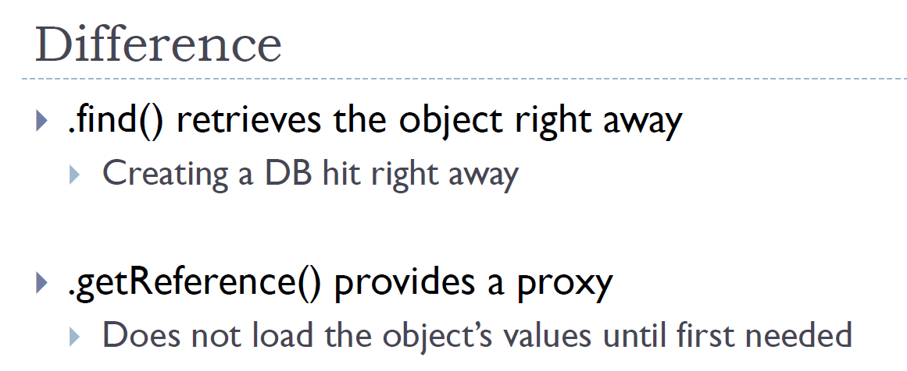

1. What’s the value of person’s name in DB after run the program? Answer: **Aaron James**

EntityManager em = *emf*.createEntityManager();  
em.getTransaction().begin();  
Person p = **new** Person(**"Aaron James"**);  
System.***out***.println(**"1"**);  
em.persist(p);  
em.detach(p);  
em.merge(p);  
p.setName(**"Updated name"**);  
System.***out***.println(**"2"**);  
em.getTransaction().commit();  
System.***out***.println(**"3"**);  
*emf*.close();